Experiment 9: Rotation of an Image Clockwise and Counter-Clockwise
Software / Tools: Python · OpenCV (cv2)

AIM
To rotate an image in the clockwise and counter-clockwise directions using OpenCV's rotation matrix.
ALGORITHM
1. Import OpenCV.
2. Read the input image and find its center point.
3. Compute a rotation matrix using cv2.getRotationMatrix2D(center, angle, scale) — a negative angle rotates clockwise, positive rotates counter-clockwise.
4. Apply the rotation matrix using cv2.warpAffine().
5. Display and save both rotated images.
PROGRAM (SOURCE CODE)
import cv2

img = cv2.imread("image.jpg")
(h, w) = img.shape[:2]
center = (w // 2, h // 2)

# Clockwise rotation (negative angle)
M_clockwise = cv2.getRotationMatrix2D(center, -45, 1.0)
rotated_clockwise = cv2.warpAffine(img, M_clockwise, (w, h))

# Counter-clockwise rotation (positive angle)
M_counter = cv2.getRotationMatrix2D(center, 45, 1.0)
rotated_counter = cv2.warpAffine(img, M_counter, (w, h))

cv2.imshow("Clockwise", rotated_clockwise)
cv2.imshow("Counter-Clockwise", rotated_counter)
cv2.waitKey(0)
cv2.destroyAllWindows()

OUTPUT
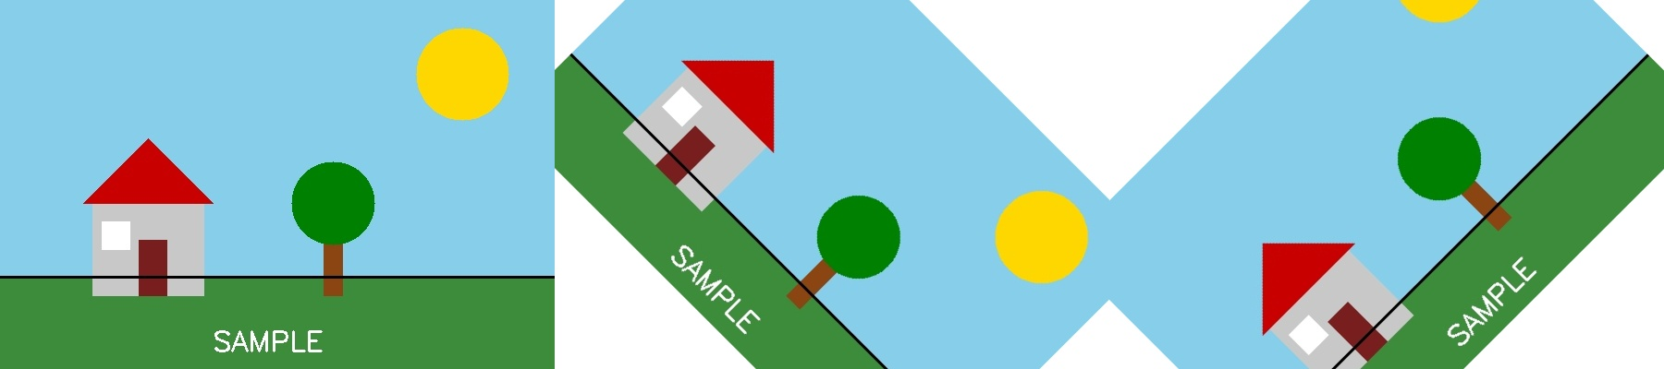
Fig. 9 — Output of Experiment 9: Rotation of an Image Clockwise and Counter-Clockwise.
RESULT
Rotate an image in the clockwise and counter-clockwise directions using OpenCV's rotation matrix — completed successfully, as demonstrated in the output shown above.

